Graphical User Manual
Third Year Computer Graphics Project
by Ewan C. Burns and Marc M. Fraser
(November 11, 2011)

Abstract 1
1 Overview of all keyboard interactions 1
2 Mouse Interactions 3
2.1 Left Mouse Button Interactions 3
2.2 Right Mouse Button Interactions 3
3 Keyboard interactions 3
3.2 Switching between scenes 3
3.2.1 Direct access scenes 4
3.2.2 Toggle access scenes 5
3.3 Display options 5
3.3.1 Placing the origin 5
3.3.2 Showing the axes 5
3.3.3 Switching between full polygon or empty polygons (wireframe) 6
3.4 Model Animation 7
3.4.1 Jaw Animation 7
3.4.2 Neck animation 7
3.4.3 Knee animation 8
3.4.4 Animation: eating a leaf from the tree 8

Abstract
This User Manual describes the different user interactions to which the animated model will respond, as part of the Computer Graphics project by Ewan C. Burns and Marc M. Fraser.

1 Overview of all keyboard interactions
This section is a brief summary and description of all keys the user is able to use when running the animated model program. See section 3 for a more details on these keyboard functions.

Keyboard Key | Function
Esc | Exits the application
s | Draws the animated model
e | Draws an E
c | Draws a C
b | Draws a B
m | Draws an M
n | Draws an N
f | Draws an F
i | Draws all six initials (M, N, F, E, C, B)
/ | Steps through all initials as well as sub-sections of the full model
o | Clickable when showing the individual initials and shows the origin of the initial (the point in which it shall rotate)
a | Toggles between a black and white background. White background required to allow the drawing of the main X, Y, Z axes.
x | When in white background mode draws the (x, y) axis
y | When in white background mode draws the (y, z) axis
z | When in white background mode draws the (x, z) axis
l | Draws transparent (wireframe) polygons
L | Draws full (non-wireframe) polygons
j | Opens the jaw
J | Closes the jaw
k | Model stands on back legs
K | Model stands back down from back legs
h | Bends the model’s neck
H | Straightens the model’s neck
p | Begins a small animation

2 Mouse Interactions
This section serves as a description of the various mouse interactions to which the animated model can respond.

2.1 Left Mouse Button Interactions
When the left mouse button is held down and the mouse moved, the angle from which the scene is viewed is rotated around the y or x axis respectively (see Figure 1 below). This gives a “drag'n'drop” type movement to the camera.
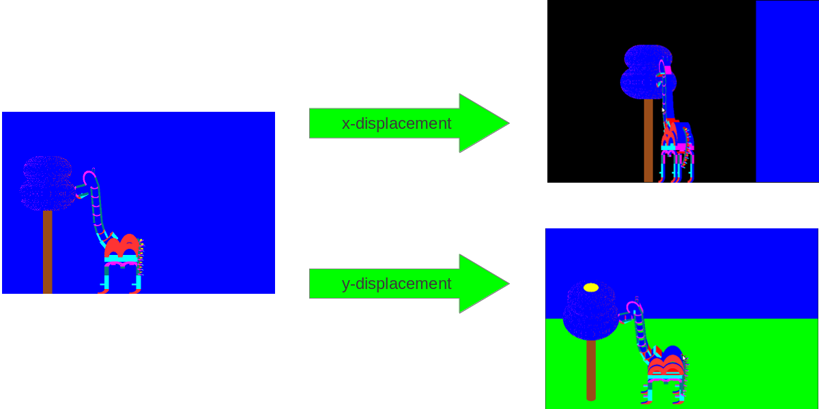
Figure 1- Effects of x and y displacements of mouse when left button is held down

2.2 Right Mouse Button Interactions
A single press of the right button will exit the program (note that the exit is on release of the button).

3 Keyboard interactions
This section serves as a description of the various keyboard interactions to which the animated model can respond.

3.2 Switching between scenes
We define the term “scene” in this context to be a view of objects that the program is capable of producing at a single time. The user is able to ask the program to draw a variety of different scenes individually, each can be accessed in two ways: direct access or toggle access.

3.2.1 Direct access scenes
There are eight scenes that can be accessed directly through the keyboard by simply pressing the following Keys:

Key | Description | Output
s | Shows the animal in full, with an animated tail action.  The user can press other keys here to see further animations, such as the opening/closing of the (j/J) jaw and the bending of the neck (h/H). | 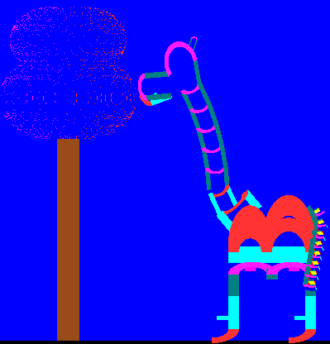
e,  c,  b,  m,  n,  f | Shows the initial corresponding to the letter pressed.
   |  | 
  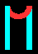 | 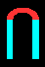 | 
i | Shows all six initials simultaneously. | 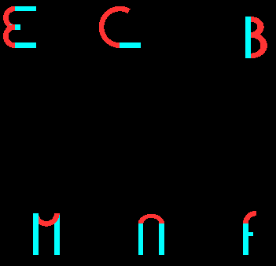

3.2.2 Toggle access scenes
Some of the other less important scenes can be access by toggling through a list of all possible displays. To toggle between these scenes, the user must press the '/' key.
For example:
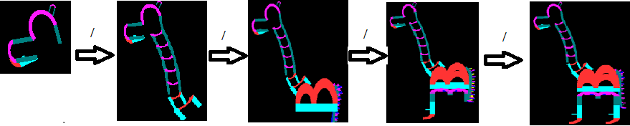

3.3 Display options
The user can change the scene slightly, in order to get a better view of how the objects are being displayed.

3.3.1 Placing the origin
When drawing the individual initials, or when drawing all six simultaneously, the user has the option of showing the origin of the letters, i.e. where the letter is centered when the function to draw the letter is called. This allows the user to better understand around which point the letter is created. This can be achieved by pressing the 'o' key. To remove this origin, press the 'o' key again. Note that when drawing the animated model, or toggling through its sub-sections, this option is not available. Figure 1 shows and example of this functionality.
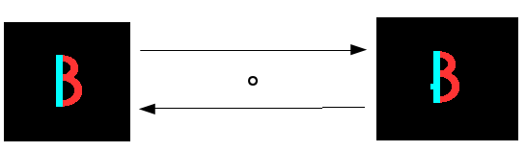
Figure 2- Example of printing the Origin for the B initial

3.3.2 Showing the axes
The user may wish to see where some of the main axes of the program are, in order to get a better understanding of where objects are placed (relative to each other or center of the 3D space). Pressing the 'a' key changes the background color to white, and also draws the x = 0, y = 0 and z = 0 lines, center of the 3D space (there point of intersection being the absolute center). Pressing the 'a' key again will revert back to the default “black background mode”.
When in the “white background mode”, the user can choose to display more axes. To get a grid of axes in the (x,y) plain, the user can press the 'x' key. The 'y' key will draw a grid of axes in the (y,z) plain, and the 'z' key will draw a grid of axes in the (x,z) plain. Pressing these keys again hides the associated grid of axes.
In Figure 3, the central image shows the effect of the 'a' key on the display. The other displays can be obtained by pressing the associate 'x', 'y' or 'z' key.
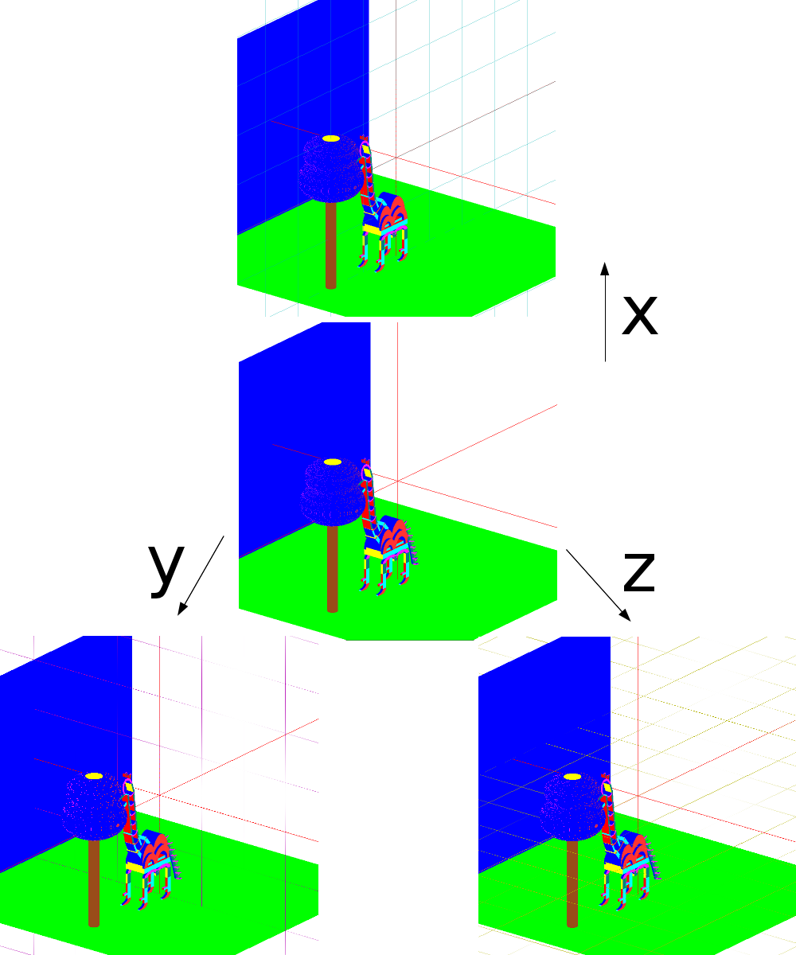
Figure 3 - Showing axes in “white background” mode

3.3.3 Switching between full polygon or empty polygons (wireframe)
By default, OpenGL polygons use linear interpolation to color the polygon. The color of the edge of a polygon is a linear interpolation of the colors of the two vertices', and the color of the polygon is a linear interpolation of the edges. You can ask OpenGL to not do this second step of interpolation, and just show clear (or empty) polygons. By pressing 'l', the user can view the scenes with empty polygons. Pressing 'L' reverts back to the default full polygon state. This is illustrated in Figure 4 below.
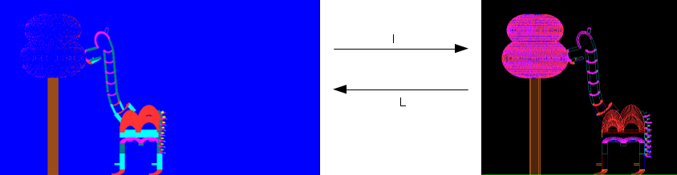
Figure 4 - Full polygon mode (left) and empty polygon mode (right)

3.4 Model Animation
As this is an animated model, certain keyboard interactions can make modifications as to the models posture. These are described below.

3.4.1 Jaw Animation
By pressing the 'j' key, the user can progressively open the model's jaw. The reverse action can be obtained using the 'J' key. The jaw has a range of motion of 20°, 0° being the default closed position. See Figure 5 for more information.

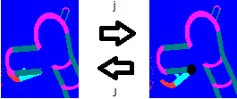
Figure 5 - Jaw animation

3.4.2 Neck animation
The 'h' key can be used to progressively tilt the base of the neck back, while bending the trunk of the neck forward. The reverse motion is obtain with the 'H' key. The neck can tilt up to 45° back, and the can range up to 90° of its initial angle. See Figure 6 for more information.
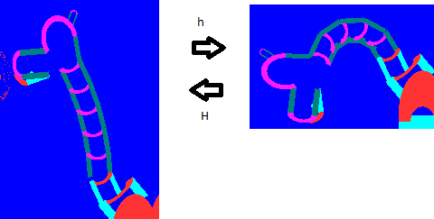
Figure 6 - Model with straight (left) or bent (right) neck

3.4.3 Knee animation
The 'k' key allows the model to progressively bend its back knees backwards to a maximum of 45°, which gives the impression the models is balancing on its back legs. The reverse motion is obtained by pressing the 'K' key. See Figure 7 for more details.

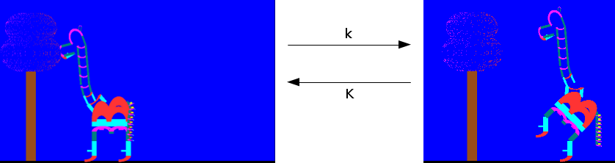
Figure 7 - Model standing up on hind legs

3.4.4 Animation: eating a leaf from the tree
When pressing the 'p' key, the model enters a short a sequenced animation, which consist of the model falling back to its default position, then jumping up to grab a leaf from the tree, before falling back down and chewing.

